DATA 252 / DATA 551: Homework 9

  - This homework is due by April 13, 2020 at the beginning of class. You need to submit your answers on Moodle in a pdf document. In addition, there will be a short quiz at the beginning of class, which might contain contents from this homework (including the assigned video), in addition to contents from the most recent lecture.

- Watch this video on using darts to estimate pi: https://www.youtube.com/watch?v= M34TO71SKGk&t=261s. Answer the following questions.

  - Is this a Monte Carlo method? Briefly explain.
Yes, because of random throwing of darts.

  - A few diﬀerent techniques of throwing darts were attempted in the video (e.g.: throwing with eyes covered or throwing a few darts at once). Discuss one technique that does not work very well and one technique that works better.
A board with only one circle covered in whole area did not worked well.
A board with multiple figures (circles with squares). + changing the orientation of board while throwing darts.

- Use Monte Carlo integration to calculate ^{R}₀³ x²dx. Provide your code.
m = 10000
x = runif(m, min=0, max=3)
mean(x^2) * 3
[1] 9.040013

- If you run the algorithm in 2 again, you would get a diﬀerent estimate. Use a for loop to run the algorithm 10000 times and store the resulting 10000 estimates. Plot a histogram of these 10000 estimates and construct a 95% confidence interval of the true value (hint: use the quantile function). Provide your code.

nsim=10000
result=rep(NA,nsim)
for(i in 1:nsim){
x = runif(m, min=0, max=3)
result[i]=mean(x^2) * 3
}
quantile(result, probs=c(0.025,0.975))

2.5% 97.5%
8.843486 9.158240

- Suppose the number of new COVID-19 cases per day in the U.S. can be modeled by the exponential function 30000 · e^{−(x−34)2/160}. Below is a plot of the actual number of new cases in the U.S., from March 4 to April 8 (36 days), with the given function overlaid (data source: https://covidtracking.com/data/us-daily).

New cases per day in the U.S.
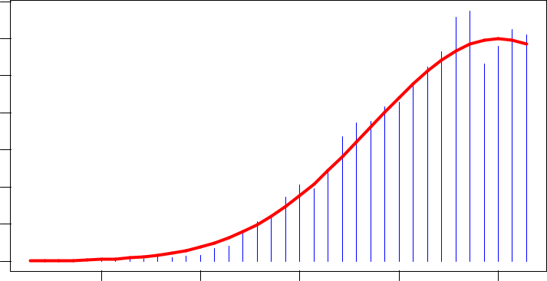

30000
20000
10000
0
Mar 09 | Mar 16 | Mar 23 | Mar 30 | Apr 06
 |  |  |  | 1

- In this setup, ^{R}₀³⁶ 30000 · e^{−(x−34)2/160}dx represents the total number of cases in the U.S. by April 8. Use Monte Carlo integration to estimate this number (the actual number is 423164, for comparison). Provide your code.

m = 1000
x = runif(m, min=0, max=36)
mean(30000 * exp(1)^-(((x-34)^2)/160)) * 36

[1] 371037.2

m = 1000
nsim=10000
result=rep(NA,nsim)
for(i in 1:nsim){
x = runif(m, min=0, max=36)
result[i]=mean(30000 * exp(1)^-(((x-34)^2)/160)) * 36
}
quantile(result, probs=c(0.025,0.975))

2.5% 97.5%
370871.5 420527.5

- Suppose we can use the given exponential function to model the number of new cases in the future. Then, for instance, ^{R}₀⁴⁰ 30000 · e^{−(x−34)2/160}dx would represent the total number of cases by April 12. Use Monte Carlo integration to estimate this number. Provide your code.

m = 1000
x = runif(m, min=0, max=40)
mean(30000 * exp(1)^-(((x-34)^2)/160)) * 40
[1] 536307.8

m = 1000
nsim=10000
result=rep(NA,nsim)
for(i in 1:nsim){
x = runif(m, min=0, max=40)
result[i]=mean(30000 * exp(1)^-(((x-34)^2)/160)) * 40
}
quantile(result,probs=c(0.025,0.975))

2.5% 97.5%
474468.5 532875.3

2

